**Kitchen Chaos**

**Summary**

**Quickly deliver the desired recipes to the delivery counter.**

Players are given a list of recipes that they need to deliver. Items needed can be obtained from different counters. Burgers need to be cooked but be careful not to burn them. Vegetables needed to be cut on the cutting counter. Once a place is assembled it can be brought to the delivery counter.

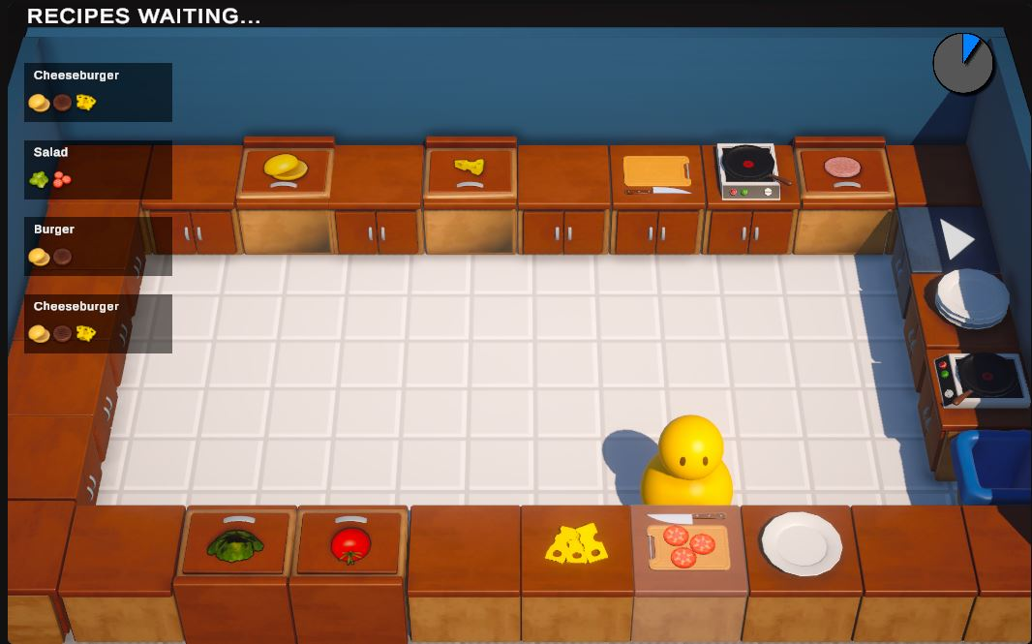

**Core**

The player is given a list of recipes, they obtain all the items needed on a plate and deliver it. There is a set limit of recipes that can be on screen, when one is completed, it goes away and will be replaced by a random one.

**Features**

Collecting, cutting, grilling, delivery.